Career Questionnaire
Thank you for your interest! Please fill out the following general information about you and then proceed to answering the questions about your career.
General Information About You
Full Name:
Email:
Position/Title:
Company:
Please bold one of the following phrases to indicate your selection.
Your position is one that you… currently hold formerly held.
Please list any prior roles pertaining to your work.

Please list any undergraduate degree(s), any graduate degree(s), and any PhD(s), as well as what university/college each of these is from.

Questions About Your Career
Note: While answering all of the questions would be most helpful, responses to each question are not required.

Please provide a quote or mantra that you feel accurately reflects both you and your profession. It can be a quote generated by you or a quote from someone else. If the quote or mantra is from someone else, please specify who generated the quote or mantra.

How did you narrow down your interest(s) to your specific profession?

When did you first realize that you were interested in your profession? If this occurred during high school, how did you pursue this interest as a high-school student?

How did you break into the industry associated with your profession? What advice would you have for a high-school student who is interested in breaking into the same industry?

What advice would you have to high-school students who are interested in a profession that is similar to yours? Is there anything specific that you suggest that these high-school students should do?

What are some aspects of your profession that the average high-school student would not know, but should know? What are some aspects that surprise you about your profession?

If you were to hire the ideal job candidate for your profession, what kind of person would you be hiring? What qualities would this person have?

What are your favorite and least-favorite parts about your profession?
Submitting Your Response
Thank you for your response. Please go to https://professionalplaybook.net/upload-a-response/. Then, click the “Upload Your Response” button. Finally, hit the “Choose Files” button, and select this file from your computer. This process is visually walked-through below. The referenced buttons are highlighted in yellow.
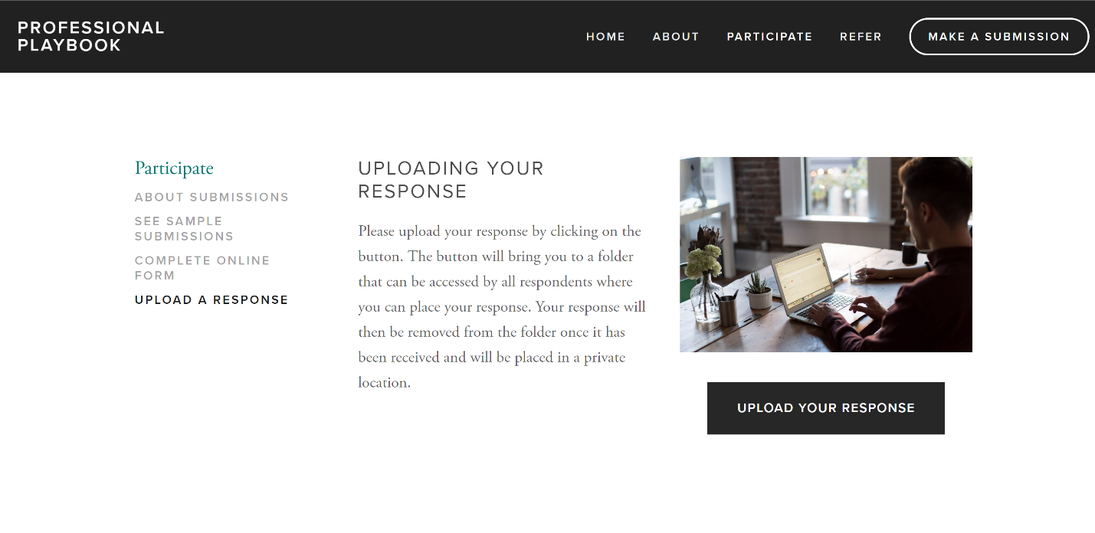
After going to the link listed above, click this button.
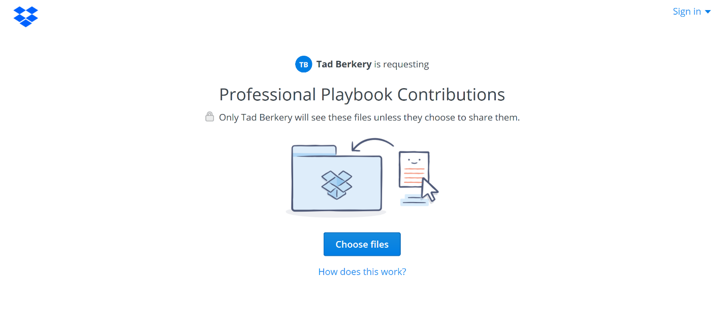
Then click this button and select this file from its location on your computer.

